NAME: Shriya Ramya Mohan EXP : 15
ROLL NO:241901106

Experiment 15
TO ANALYZE THE DIFFERENT TYPES OF SERVERS USING WEBLIZERS

AIM:
To analyse web server log files using Webalizer to generate detailed usage statistics and reports for Apache, Nginx, and other web servers.
ALGORITHM:
- Install the tool using package manager (apt/yum) on Linux/Unix system.
- Identify web server log files (Apache at /var/log/httpd/access_log, Nginx at /var/log/nginx/access.log).
- Edit configuration file (/etc/webalizer.conf) to specify log file location, output directory, and hostname.
- Create directory where HTML reports will be saved (e.g., /var/www/usage).Execute command webalizer or webalizer -c configfile to process logs.
- Tool reads log entries, extracts IP addresses, pages accessed, referrers, browsers, timestamps.
- Creates HTML pages and graphs showing monthly, daily, hourly statistics with tables and charts.
- Access generated HTML reports in browser to view traffic statistics and analyses.
OUTPUT:
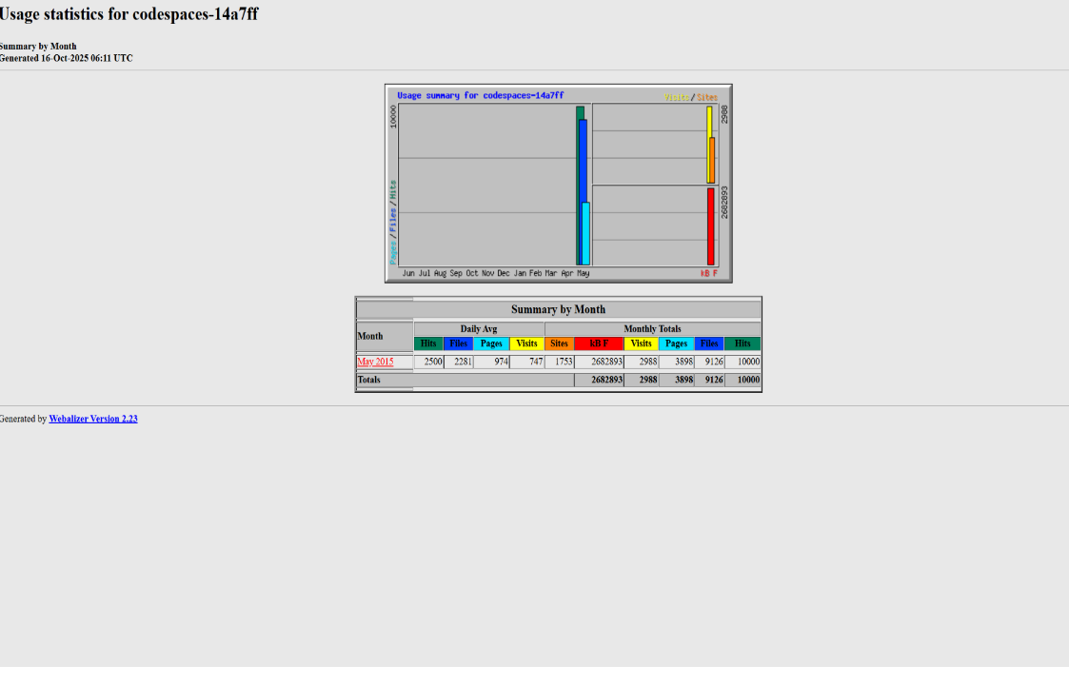
1. MONTHLY SUMMARY
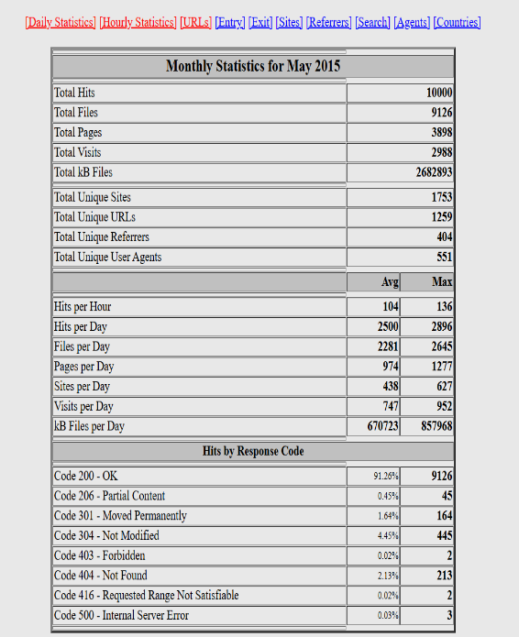

2. DAILY AND HOURLY GRAPHS:
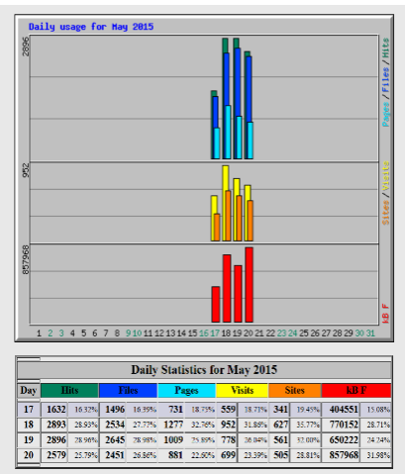
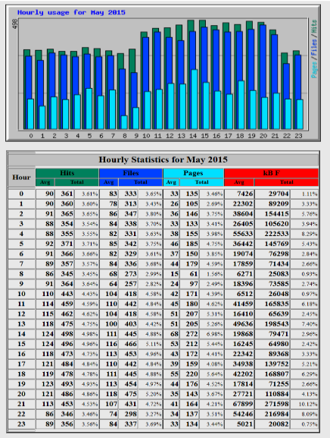
3. TOP URLS
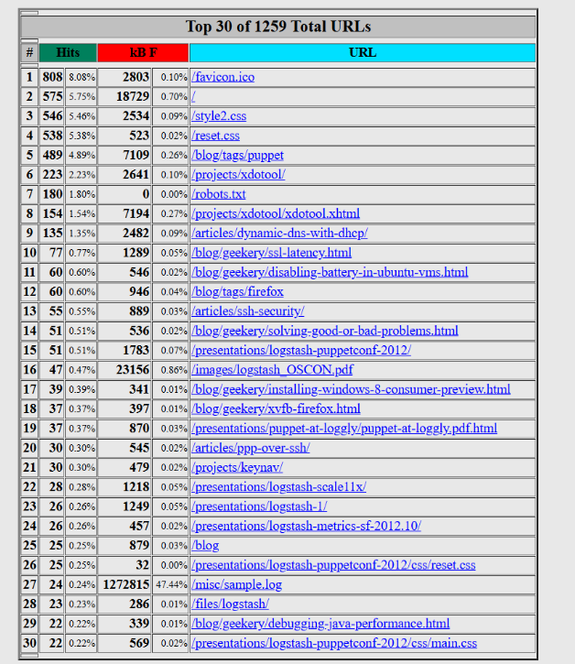
4. ENTRY AND EXIT PAGES
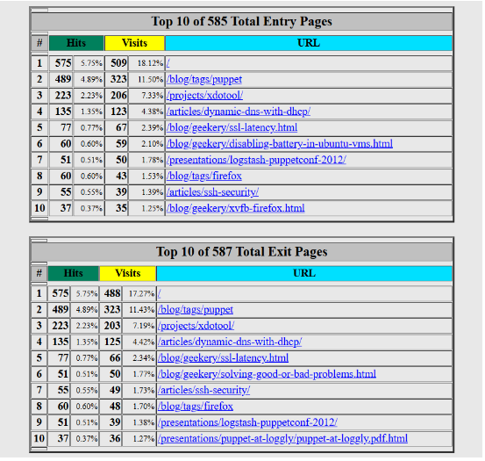
5. TOP SITES
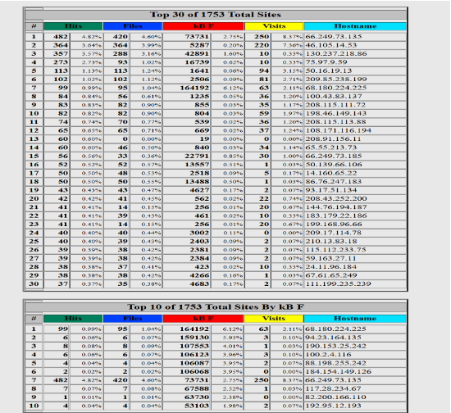

6. TOP REFERENCES
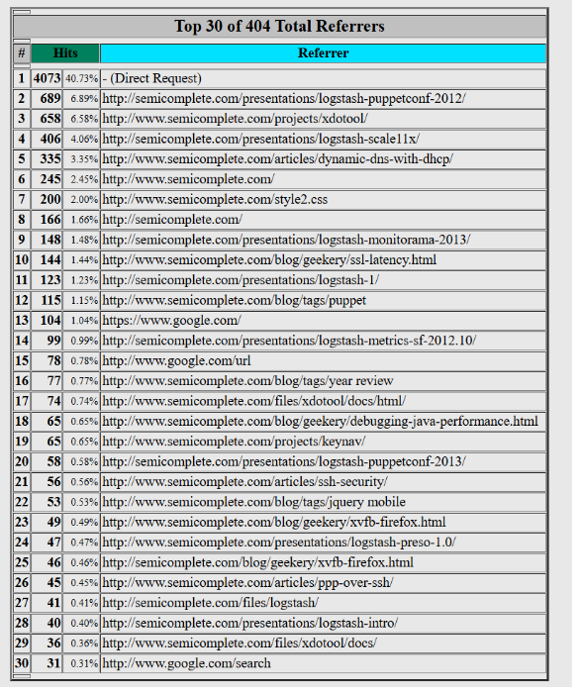
7. AGENTS
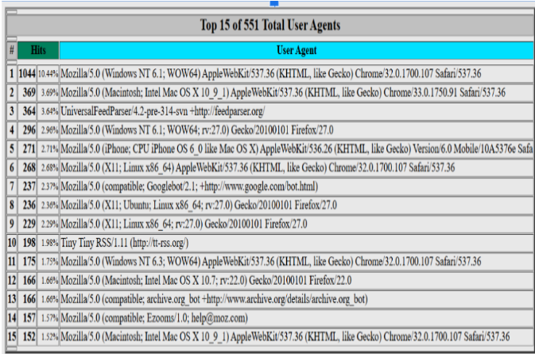

8. COUNTRIES AND DOMAINS
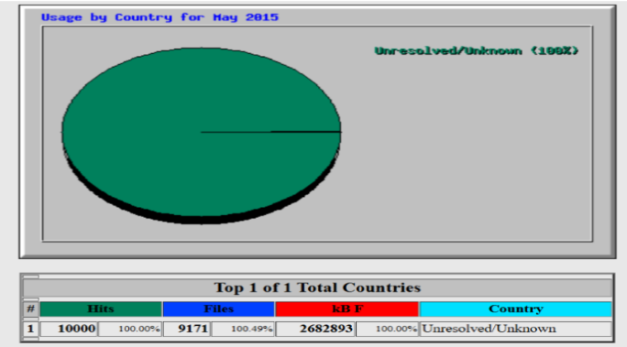

RESULT:
Webalizer successfully analyses web server logs from Apache, Nginx, ProFTPD, and Squid servers, generating detailed HTML reports showing visitor traffic patterns and server usage. The tool processes large log files quickly (up to 70,000 records per second) and provides actionable insights for server optimisation and traffic understanding.
- owing visitor traffic patterns and server usage. The

